Who’d have guessed: Whale poop keeps fish on your plate – and helps reduce global warming too
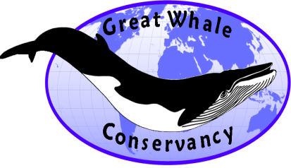
It’s been just in the past few years that scientists have been able to construct an overview of what drives, and maintains the health of, marine ecosystems – and it is probably not what you’d guess if you’re playing Trivial Pursuit. This story starts when scientists tried to explain why the abundance of krill (small shrimp-like creatures that are near the bottom of the food chain) in the Southern Ocean is lower today, 30 years after commercial whaling ended and after 2 million whales had been killed in these waters, than it was during the “pristine” period before commercial whaling began.

How does this pan out? Krill are hard to estimate, especially in waters as notoriously rough and remote as the Southern Ocean, but an estimate in 2009 following 10 years of searching concluded that the total global biomass of this creature is 133 million tons. The stomach contents of more than 500 great whales killed during the industrial whaling period indicates that the estimated total population of 1.7 million whales prior to industrial commercial whaling in the Southern Ocean would have consumed 276 million tons of krill a year – that is, the feeding requirement of the whales known to have been killed is twice the present biomass of krill.

So what gives? Normally, if an apex predator is removed from the ecosystem, there’s a “predatory rebound”– that is, the prey population explodes. Moose, deer, and elk proliferated across the U.S. after the extermination of wolves and mountain lions. The loss of these predators set off a “trophic cascade” that resulted in broad ecosystem changes. Krill are also consumed by seabirds, seals, squid, and fish, but no commensurate increase in the abundance of these animals has been noted. So something is different in the oceans than in terrestrial systems, where coyotes often fill the wolves’ space. In the oceans, there’s been no measurable “compensatory predation” on krill by other animals.

Thus, krill abundance has declined by as much as 50% since the start of commercial whaling, and actually continues to drop. Might this be due to global warming melting the ice sheets under which ice algae, a favored krill food, are found? Unlikely, since the ice sheets are nowadays somewhat larger than they were during the late 1900s. What appears to be true is that removing whales, with their nutrient-rich feces and urine, has impaired the productivity of phytoplankton, the krill’s food. In fact, it seems that whales and krill acting together were ecosystem engineers. Pelagic marine species (that is, open-ocean species like whales and krill) affect their environment in two ways: nutrient release (that is, defecation or decay) and turbulence from their passage through the water.

To add intricacy to an already abundantly complex situation, it appears that the behavior of krill has changed since the onset of commercial whaling. Once they were found in huge swathes at the ocean’s surface at all hours of the day; now they appear to spend daylight hours at depth, rising to the surface to feed at night. Very large schools of krill on the surface during daylight were reported by whaling vessels and scientific expeditions [‘constant records of krill in sight day after day’, ‘thick with [krill] like pea soup’, and ‘immense pastures’]; in the l950s and 60s, scientific observers mapped surface schools and concluded that krill only inhabited the top 10 m and rarely went below 40 m. This is definitely not the case now; there are no observations of large schools of krill on the surface during the daylight reported in recent scientific literature. In the Southern Ocean, they are now found on the surface only at night.

An intriguing piece of evidence is that krill are attracted to substances rich in iron. One experiment using, of all things, iron-rich Newcastle Brown Ale, described krill as having to be pried off the end of the pipette introducing the beer into their tank. It is likely that whale feces (and the iron these contain) attract krill to the surface, which in turn attracts whales to feed on the krill and produce more poop (whales invariably defecate at the surface), continuing the cycle.

If krill no longer come to the surface except at night, what is the likely impact of this on the marine ecosystem, especially when coupled with the decrease in krill biomass? Ecologists have only recently begun to recognize the importance of animals in the recycling of crucial elements such as phosphorous in maintaining the health of terrestrial ecosystems. Whales bring phosphorus, nitrogen, and micronutrients such as iron from the ocean’s depths to the surface, inducing krill to remain near the surface as well as providing essential nutrients and food for efficient reproduction. This increased productivity feeds seabirds and anadromous fish (those that spend part of their lives in marine waters, part in fresh). Imagine then a healthy interlinked biome where whales pump nutrients from the depths to the surface, with the resulting krill blooms feeding salmon. The fish swim upriver, where they are fed on by bears, otters, and eagles. These in turn defecate on the terrestrial side, which fertilizes plants for the herbivores that graze there. Sound farfetched? It has been demonstrated in near-stream soil, vegetation, and insects in British Colombia, Canada. Marine nutrients too have been found in trees far from streams in British Columbia, likely transported by salmon-eating bears. Indications are that it occurs in the Gulf of Maine, where whales and seals pump four times as much nitrogen into the ocean’s productive upper layer, the euphotic zone – that is, the layer of the ocean where light penetrates – as all the rivers in the area combined.

What does this mean in practical terms? It’s likely that humanity has shot itself in the foot on multiple levels. With the human population set to reach 11 billion by mid-century, we urgently need healthy and productive oceans to provide the protein for the roughly 3 billion people dependent on marine resources, and fish on the plate for we who consume it by choice. Just as much as we need to maximize mangroves and sea grass plains– the nurseries for many fish species – we need the great whales to move nutrients from the depths to the surface and then laterally outwards to enhance fish stocks. The destruction of the great whales is shocking in its extent: ecologists now estimate that whale numbers globally have been reduced by 66% to 90% of what they were a thousand years ago (when coastal whaling was first documented by Basques), and that industrial whaling in the Southern Ocean has reduced blue whales by 99%. An estimated 5 million great whales have been killed during the whaling millennium, almost 3 million by industrial whaling during the 20th century. This decimation of whale populations means that their transport of vital nutrients vertically has been reduced to just 23% of what it once was, and laterally not by one-quarter, not by half, but by a staggering 95% averaged across the globe. Averages, however, don’t give the whole picture. Many of the great whale species feed in productive polar and temperate waters, but migrate to calving grounds in the tropics and sub-tropics. And while they may eat little when in these warm but less-productive areas, their metabolic processes continue – a conveyor belt, then, of nutrients from cold to warm seas.

To conclude, most of the world’s large fisheries occur in surface waters. Whales enrich surface ecosystems by pumping nutrients from the deep ocean to the surface, where they breathe and rest. Maintaining or increasing whale numbers can be a significant long-term strategy for the enhancement of the building blocks of the marine food chain and the restoration of fish populations.

There’s one more piece to be fitted into this puzzle, and it concerns global warming. The great whales once excreted tons of nutrients into the euphotic zone, where photosynthesis takes place. In this zone, phytoplankton produce most of the ocean’s net primary productivity (NPP). Even in their diminished abundance, whales help us breathe: phytoplankton make up 46% of Earth’s entire NPP, and provide nearly half of the planet’s oxygen. Although it constitutes just 0.2% of global biomass, phytoplankton can bloom when whales fertilize the oceans with nutrients such as nitrogen, phosphorus, and iron. Some of this additional phytoplankton is consumed by zooplankton such as krill and copepods; the remainder drifts down into the depths, storing carbon for decades and even millennia.

There is a summer maximum in the northern oceans’ NPP, largely a result of open-ocean blooms north of 30°N; but despite the greater ocean area in the Southern Hemisphere, a similar bloom-induced increase in NPP does not occur during the Austral summer. This seems to be due to the common occurrence of micronutrient deficiencies (particularly iron limitation) in the cold southern oceans surrounding Antarctica - in which the absence of the great whales may well play a significant role. On the other hand, phytoplankton NPP declines as waters warm because of nitrogen and phosphorus macronutrient deficiencies. Nutrients from whales shift the NPP system away from a tightly regenerating loop based on small phytoplankton (typically bacteria-based) toward a community with a higher proportion of larger phytoplankton (typically multi-celled phytoplankton – the types more useful for fish) and, consequently, more carbon export. The conclusion, then, is that if we help whale populations to increase, the magnitude of the whale pump/ conveyor belt will also grow, helping to mitigate the impact of our fossil fuel use. And in a warmer world with greater temperature stratification of the oceans, the whale pump is likely to prove even more important than it was in the past.

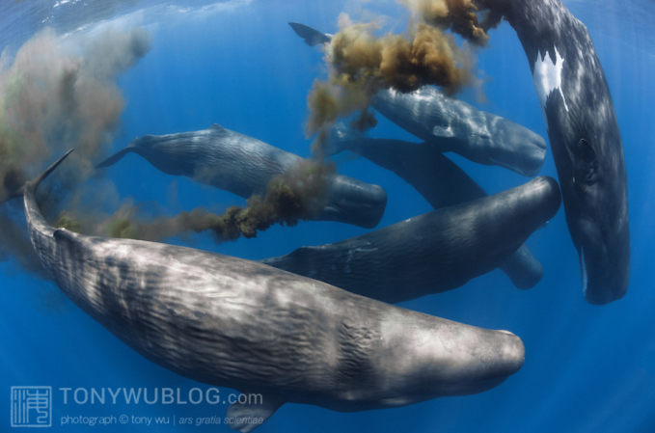 | We know that most of the oxygen in the atmosphere is generated -- and much of the carbon dioxide is taken up -- by mangroves, marshes, sea grasses, algae and especially microscopic phytoplankton in the ocean. Quite simply, no ocean, no life. No blue, no green. If not for the ocean, there would be no climate to discuss or anyone around to debate the issues. Oceanographer and National Geographic explorer Sylvia Earle, 2014.  The fecal plume of a sperm whale.  Photo: Tony Wu, used by permission.

The Whale Pump
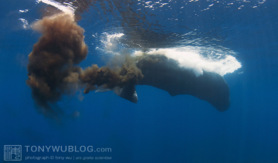
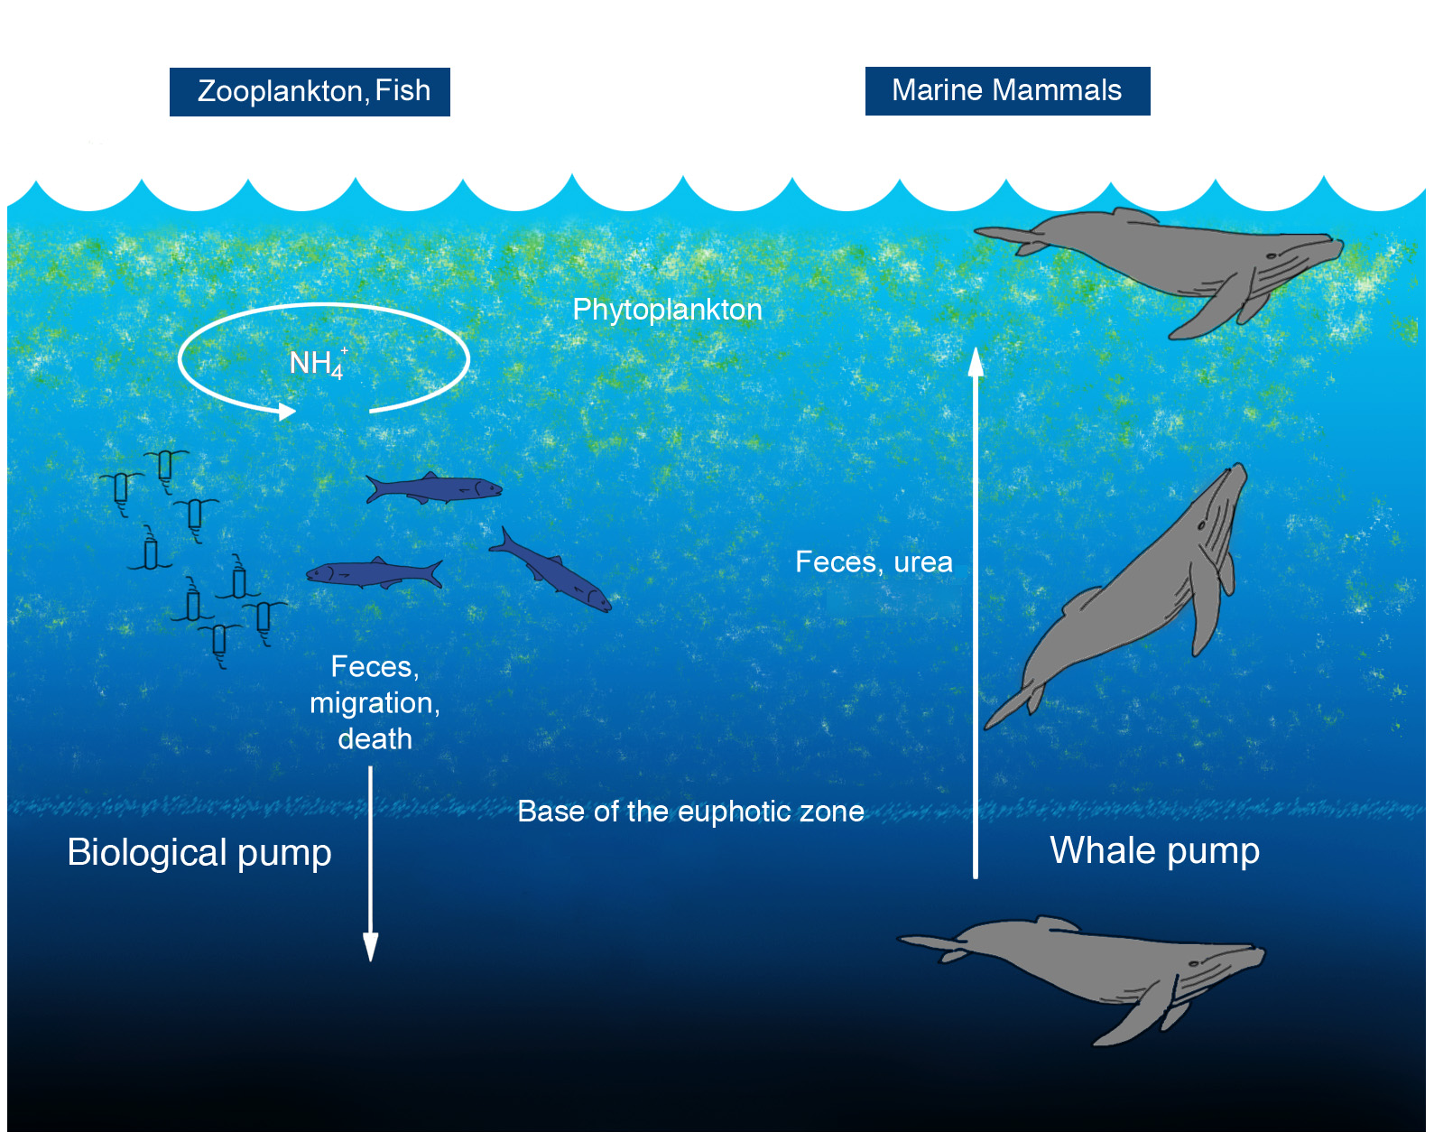
The Hawaiian sperm whale population of only 80 whales is estimated to transport 1,000 tons of nutrients to surface waters per year, and stimulate sequestration of 600 tons of carbon per year.
Blue whales in the Southern Ocean (at 1% of pre-whaling levels) are estimated to transport 88 tons of nitrogen annually to their birthing grounds in tropical latitudes
As the biological pump is understood, zooplankton feed on phytoplankton in the euphotic zone and export nutrients via sinking fecal pellets, and vertical migration. Fish typically release nutrients at the same depth at which they feed. Excretion for marine mammals, tethered as they are to the surface for respiration, is shallower in the water column than where they feed. NH4 = ammonium, the scarcest nutrient in surface waters relative to the amounts needed by phytoplankton. Photo of sperm whale defecating: Tony Wu, used by permission.

The great whales’ relative contribution of nitrogen into the Gulf of Maine
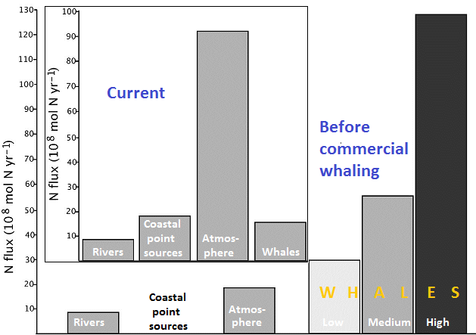
The movement of nitrogen into the Gulf of Maine at present (“current”) compared to the era before commercial whaling began. Today, point sources (fertilizer and effluent runoff from farms and cities) is slightly larger than the contributions from whales, but in pre-whaling years was near-zero. The atmosphere currently provides the largest amount of nitrogen to the Gulf in the form of dust, man-made pollutants from smokestacks and tailpipes, and natural deposition of N-compounds. Note that in pre-whaling era, even the low population estimate of whales exceeded, by a considerable margin, atmospheric deposition – which is the ideal situation today, too, if we can fully contend with our air pollution problem. Note that seasonally, whales contribute seven times more nitrogen to the euphotic zone during the summer – when it is most needed – than in winter.

Further Reading

Some of these scientific papers are available on Wiley-online or Researchgate, a forum for information exchange among scientists. Members of the public are restricted in accessing these sites. Contact us if you would like to read these journal articles.

Alexandera, H., M. Roucoc, S.T. Haley, S.T. Wilson, D.M. Karl, and S.T. Dyhrman, 2015. Functional group-specific traits drive phytoplankton dynamics in the oligotrophic ocean. Proceedings of the National Academy of Sciences. http://www.researchgate.net/publication/282811820 and http://www.pnas.org/content/112/44/E5972.abstract

Doughty, C.E., J. Roman, S. Faurby, A. Wolf, A. Haque, E.S. Bakker, Y. Malhi, J.B. Dunning, and J.C. Svenning, 2015. Global nutrient transport in a world of giants. Proceedings of the National Academy of Sciences. www.pnas.org/cgi/doi/10.1073/pnas.1502549112

Kudela, R., undated PowerPoint lecture. http://ic.ucsc.edu/~kudela/OS130/Lectures/OS130S14_scales.pdf

Lavery T.J., B. Roudnew, J. Seymour, J.G. Mitchell, V. Smetacek, and S. Nicol, 2014. Whales sustain fisheries: Blue whales stimulate primary production in the Southern Ocean. Marine Mammal Science 30:3, 888–904. http://onlinelibrary.wiley.com/doi/10.1111/mms.12108/full

Lutz, S.J. and A.H. Martin, 2014. Fish Carbon: Exploring Marine Vertebrate Carbon Services. Published by GRID-Arendal, A Centre Collaborating with UNEP, Norway. http://iwlearn.net/publications/ll/fish-carbon-2013-meeting-the-climate-change-challenge

National Geographic, undated. Krill. http://animals.nationalgeographic.com/animals/invertebrates/krill/

National Snow and Ice Data Center, 2015. http://nsidc.org/arcticseaicenews/2015/10/antarctic-sea-ice-at-its-2015-maximum/

Rocha, R.C. Jr., P.J. Clapham, and Y.V. Ivashchenko, 2015. Emptying the oceans: A summary of industrial whaling catches in the 20th century. Marine Fisheries Review 76:4, 37-48. http://spo.nmfs.noaa.gov/mfr764/mfr7643.pdf

Ratnarajah , L, J. Melbourne-Thomas ,·M.P. Marzloff, D. Lannuzel, K.M. Meiners, F. Chever, S. Nicol , and A.R. Bowie, 2016. A preliminary model of iron fertilisation by baleen whales and Antarctic krill in the Southern Ocean: Sensitivity of primary productivity estimates to parameter uncertainty. Ecological Modelling 320: 203-212. https://www.researchgate.net/publication/283700250_A_preliminary_model_of_iron_fertilisation_by_baleen_whales_and_Antarctic_krill_in_the_Southern_Ocean_Sensitivity_of_primary_productivity_estimates_to_parameter_uncertainty

Roman J. and J.J. McCarthy, 2010. The Whale Pump: Marine mammals enhance primary productivity in a coastal basin. PLoS ONE 5:10. journals.plos.org/plosone/article?id=10.1371/journal.pone.0013255

Roman, J., J.A. Estes, L. Morissette, C. Smith, D. Costa, J.B. Nation, J. McCarthy, S. Nicol, A. Pershing, and Victor Smetacek, 2014. Whales as marine ecosystem engineers. Frontiers in Ecology and the Environment 12:7, 377-385. http://www.joeroman.com/wordpress/wp-content/uploads/2014/09/roman-frontiers.pdf

Smith, T.D., R.R. Reeves, E.A. Josephson, and J.N. Lund, 2012. Spatial and seasonal distribution of American whaling and whales in the Age of Sail. PLoS ONE 7:4. http://journals.plos.org/plosone/article?id=10.1371/journal.pone.0034905

Terborgh, J. and J.A. Estes (eds.), 2010. Trophic Cascades: Predators, Prey, and the Changing Dynamics of Nature. Island Press, 488 pp.

The Guardian, 2015. Water too warm for cod in US Gulf of Maine as stocks near collapse. www.theguardian.com/environment/2015/0ct/30/water-too-warm-for-cod-in-us-gulf-of-maine-as-stocks-near-collapse

Willis, J., 2007. Could whales have maintained a hIgh abundance of krill? Evolutionary Ecology Research 9: 651-662. http://www.evolutionary-ecology.com/abstracts/v09n04/hhar2181.pdf

Willis, J., 2014. Whales maintained a high abundance of krill; both are ecosystem engineers in the Southern Ocean. Marine Ecology Progress Series 513: 51-69. http://www.int-res.com/abstracts/meps/v513/p51-69/

Wing, S.R., L. Jack, O. Shatova, J.J. Leichter, D. Barr, R.D. Frew, and M. Gault-Ringold, 2014. Seabirds and marine mammals redistribute bioavailable iron in the Southern Ocean. Marine Ecology Progress Series 510: 1–13. http://www.int-res.com/articles/feature/m510p001.pdf

